Multi-Rotator——RS100
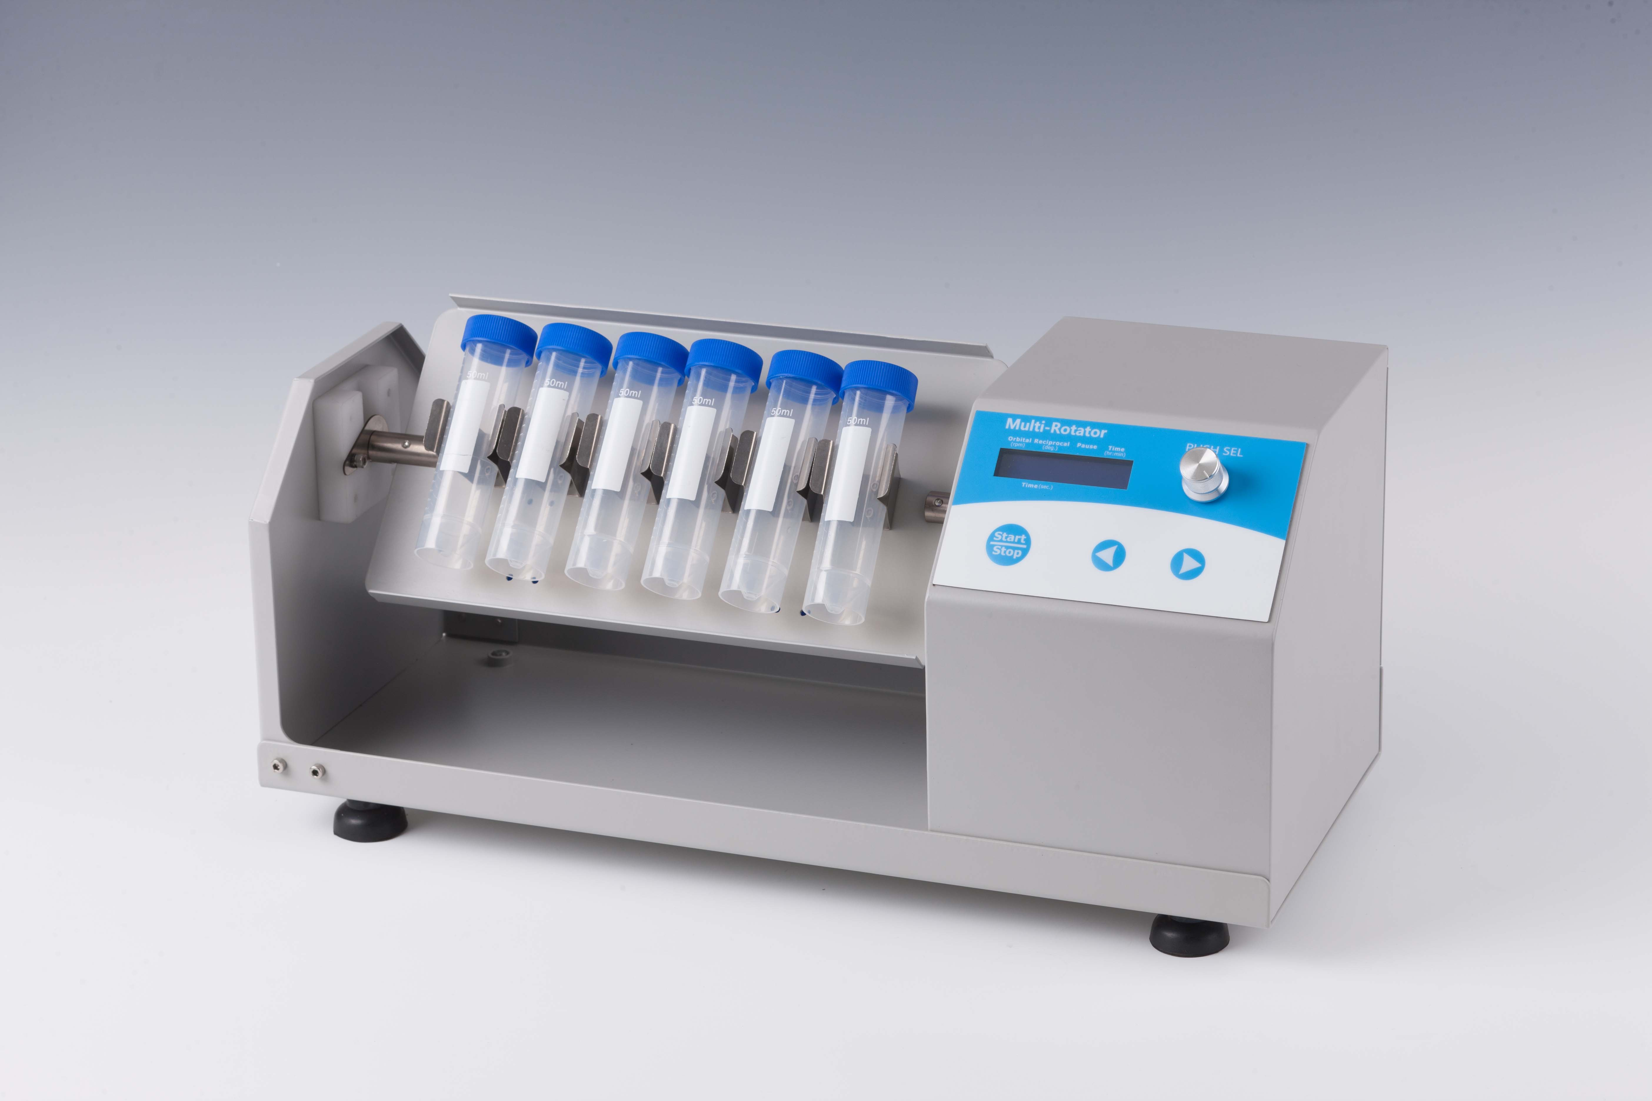
Description:
Multi-Rotator is a high speed shaker with brushless DC motor and microprocessor controlled technique. Mix and culture many kinds of centrifuge tubes, by changing different platforms. It can be applicable in different laboratories: biotechnology, microbiology and medicine analysis, etc.

Features：
- LCD displays time and shaking speed.
- Easy to operate with touch knob.
- Setup the time of 1min~99h59min. Beep alarms when operation ends.
- Different platforms can be chosen for variety demands.
- Gentle and reliable shaking with brushless DC motor.
- Programmable motions include: 1) orbital rotational motion, 2) reciprocal motion, 3) pause. Not only run in one particular type, but also alternate motions of different types cyclically.
Parameters:
Model | RS100
Shaking speed | 10~100rpm
Timing range | 1min-99h59min
Time for orbital rotational and reciprocal motions | 1-250s
Time for pause | 1-5s
Max. load | 6kg
Power | 25W
Voltage | AC110~240V, 50/60Hz
Dimension(mm) | 485x200x226
Weight(kg) | 5.90

Optional Platforms:
Type | Picture | Description
PRS-01 |  | Two sides can accommodate 44 tubes of 1.5ml/2.0ml vertically
PRS-02 |  | Two sides can accommodate 40 tubes of 1.5ml/2.0ml horizontally
PRS-03 |  | Two sides can accommodate 32 tubes of 5ml vertically
PRS-04 |  | Two sides can accommodate 40 tubes of 5ml horizontally
PRS-05 |  | Two sides can accommodate 12 tubes of 10ml/15ml vertically
PRS-06 |  | Two sides can accommodate 16 tubes of 10ml/15ml horizontally
PRS-07 |  | Two sides can accommodate 12 tubes of 50ml vertically
PRS-08 |  | Two sides can accommodate 16 tubes of 50ml horizontally

Optional Platforms:
Type | Description
PRS-01 | Two sides can accommodate 44 tubes of 1.5ml vertically
PRS-02 | Two sides can accommodate 40 tubes of 1.5ml horizontally
PRS-03 | Two sides can accommodate 32 tubes of 5ml vertically
PRS-04 | Two sides can accommodate 40 tubes of 5ml horizontally
PRS-05 | Two sides can accommodate 12 tubes of 10ml/15ml vertically
PRS-06 | Two sides can accommodate 16 tubes of 10ml/15ml horizontally
PRS-07 | Two sides can accommodate 12 tubes of 50ml vertically
PRS-08 | Two sides can accommodate 16 tubes of 50ml horizontally

